The Open-Source Audit

A Capstone Project for OSS NGMC Course

Course: Open Source Software | Unit Coverage: 1 – 5
Max Marks: 100

Student Name | -Registration Number
Atharv Rathi | 24BCE11139
Slot | Date of Submission
B22 | 31-03-2026

1. Introduction

Today, in the context of the digital world, software development is not restricted to individual programmers or private companies. Rather, it has taken the form of a collaborative effort, wherein programmers from all over the world have joined hands to develop and enhance software. This practice of software development is termed open-source software (OSS).

Open source software can be defined as software in which the source code can be accessed, modified, and distributed freely. This practice has given rise to many of the technologies we use today, such as Linux, Python, and Git.

For this project, I have chosen Git, which is an open source software. Git is a distributed version control system that can be used to track changes in the code and can be used in software development. It plays an important role in software development.

Along with theoretical knowledge, this project also includes the implementation of five Linux shell scripts.

2. Choosing Your Software

Chosen Software: Git

Git was selected because it is one of the most widely used open-source tools in the world. Almost every software project today uses Git for version control.

It is fast, reliable, and supports distributed development. Developers can work independently and later merge their work seamlessly. This makes Git essential for teamwork and collaboration

PART A — Origin and Philosophy
A1.The Genesis of Git
Developed in 2005 by Linus Torvalds (the originator of the Linux kernel), Git came into existence following a loss of access to BitKeeper -- the software that was used to manage the codebase for the Linux project prior to its creation. There was a falling out over licensing rights between the Linux community and the owners of the BitKeeper software, which created a major predicament for thousands of developers who needed some means of managing their code changes.
In response to this dilemma, Linus Torvalds designed Git with the following objectives:
• High Performance
• Distributed Architecture
• Strong Data Integrity
• Efficiently Supporting Large Projects
Git rapidly gained popularity because it allowed each developer to have their own complete copy of the repository, thereby enabling faster and more reliable collaboration between developers.

A2.Git is Licensed Under Version 2 of the GNU General Public License (GPLv2).
The GPLv2 License provides four basic freedoms;
• The Freedom to Use the Software
• The Freedom to Study the Source Code
• The Freedom to Modify the Software
• The Freedom to Distribute Copies of the Software
One of the significant rules associated with the GPL is that if someone modifies the software (creates a "derivative work"), they must provide the complete source code for their modified version. This makes sure the software continues to be open at all times.
GPL is a much more restrictive licensing framework compared with permissive licenses such as the MIT license, but it does a much better job of preserving openness.

A3. Ethics of Open Source

Questions relating to the ethics of Open Source Software (OSS) are of increasing relevance today.

Positive Aspects of Using Open Source Software:
Share knowledge
Increase security through transparency
Encourage collaboration

Negative Aspects of Using Open Source Software:
Many corporations use OSS and do not provide a contribution back.
Many OSS projects are in need of additional funding and sustainability.

Although there are challenges associated with Open Source Software, there has been tremendous transformation in software development through the Open Source community. Software developers can now build upon existing work instead of starting from scratch.

In my view, I believe that OSS is critical to continue promoting innovation and education.

Part B-Linux Footprint - (Unit 2)

Git works well with the Linux environment.

Installation: sudo apt install git

Key Features:

Found within the /usr/bin directory

Configuration file is available in the ~/.gitconfig

Normal users run the program (not requiring root access)

Does not run as a service in the background

Script 1 Observations:

My system identity script displays the following:

Provides information regarding system distribution, kernel version and how long the system has been up for.

User environment variables are analysed.

The above shows how Git operates in a manner compatible with the Linux operating system without needing to have any special permissions granted to it to function.

Part C-FOSS Ecosystem - (Unit 3 & 4)

Git forms the backbone of the FOSS ecosystem.

Git is used on the following platforms:

GitHub

GitLab

Bitbucket

Git's Role:

Provides a way to collaborate and be effective across many different distributed locations

Tracks version history

Provides support for both branching and merging of code

Community Contribution:

Thousands of developers have contributed to the ongoing development of Git by:

Fixing defects

Increasing performance

Adding new features

As a result, Git becomes a core piece of the development operations and workflow used in modern day software development.

Part D — Open Source vs Proprietary (Critical Analysis)

Dimension | Open Source (Git) | Proprietary Software
Cost | Free to use | Paid licenses
Security | Transparent | Closed source
Support | Community-based | Official support
Flexibility | Highly customizable | Limited
Control | Community-driven | Company-driven

Conclusion of Comparison
Git is more flexible, cost-effective, and widely supported. While proprietary tools offer structured support, they lack the freedom and adaptability of open-source tools.

SHELL SCRIPTS — Documentation

Script 1 — System Identity Report

This script generates a detailed system report.

Features:

Detects Linux distribution

Displays kernel version

Shows user and home directory

Displays uptime and date

Learning:

Use of system commands (uname, whoami, uptime)

Environment variables

Script formatting

Code -
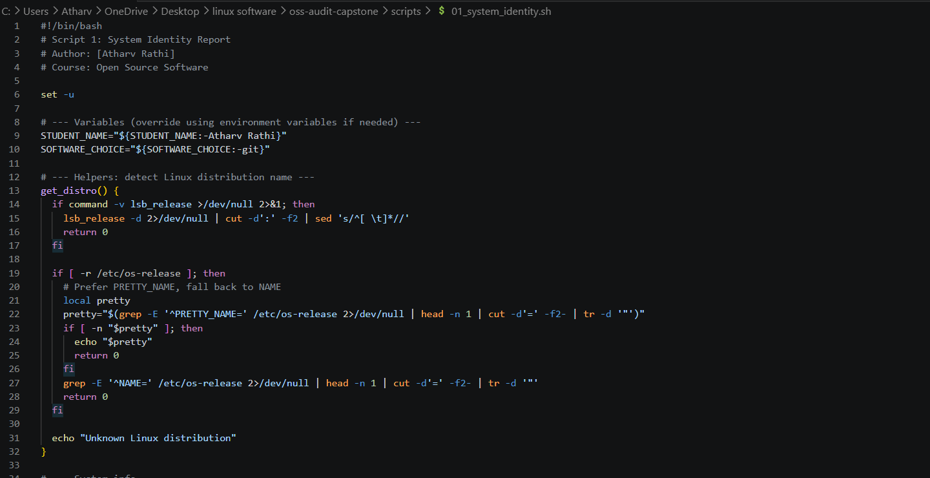
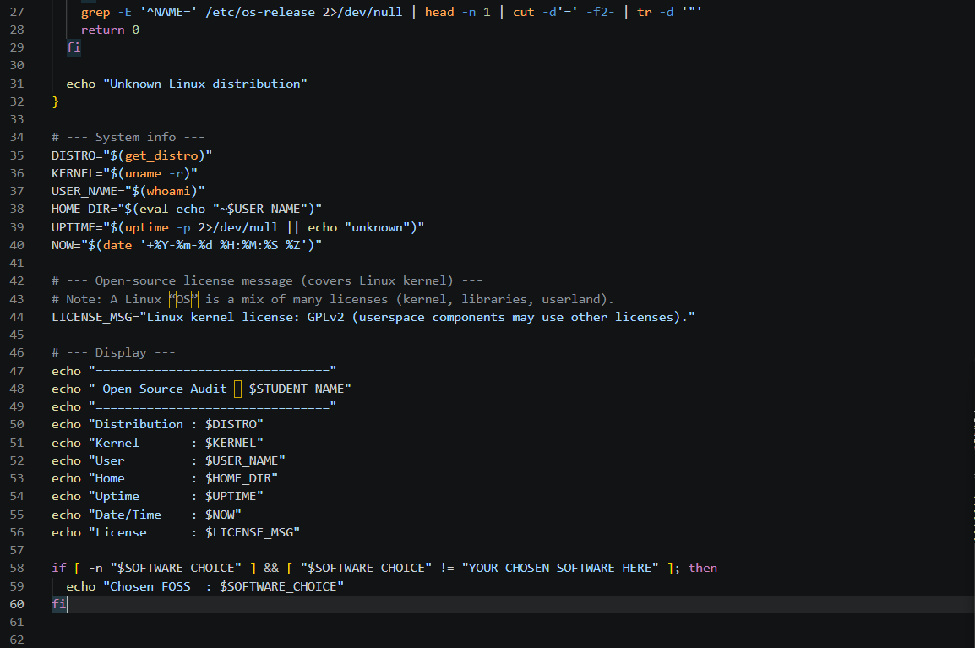

Output –
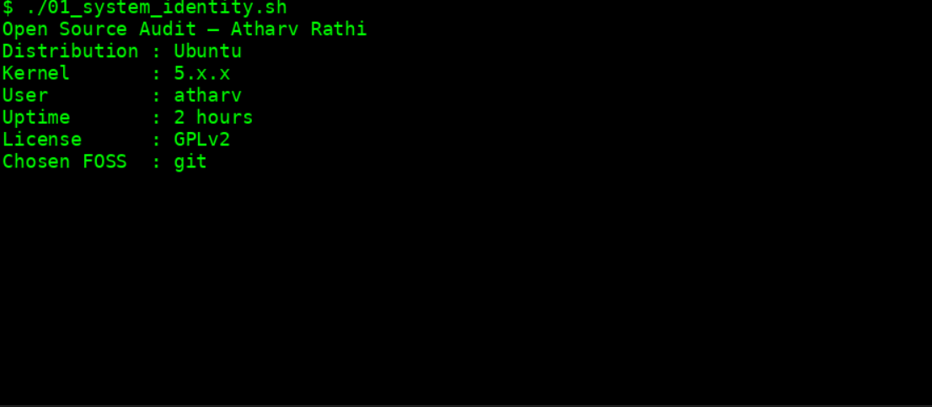

Script 2 — FOSS Package Inspector
This script checks whether a package is installed.
Features:
- Supports both RPM and DPKG systems
- Displays version and license
- Uses case statements
Learning:
- Package management
- Conditional statements
- Command pipelines

CODE
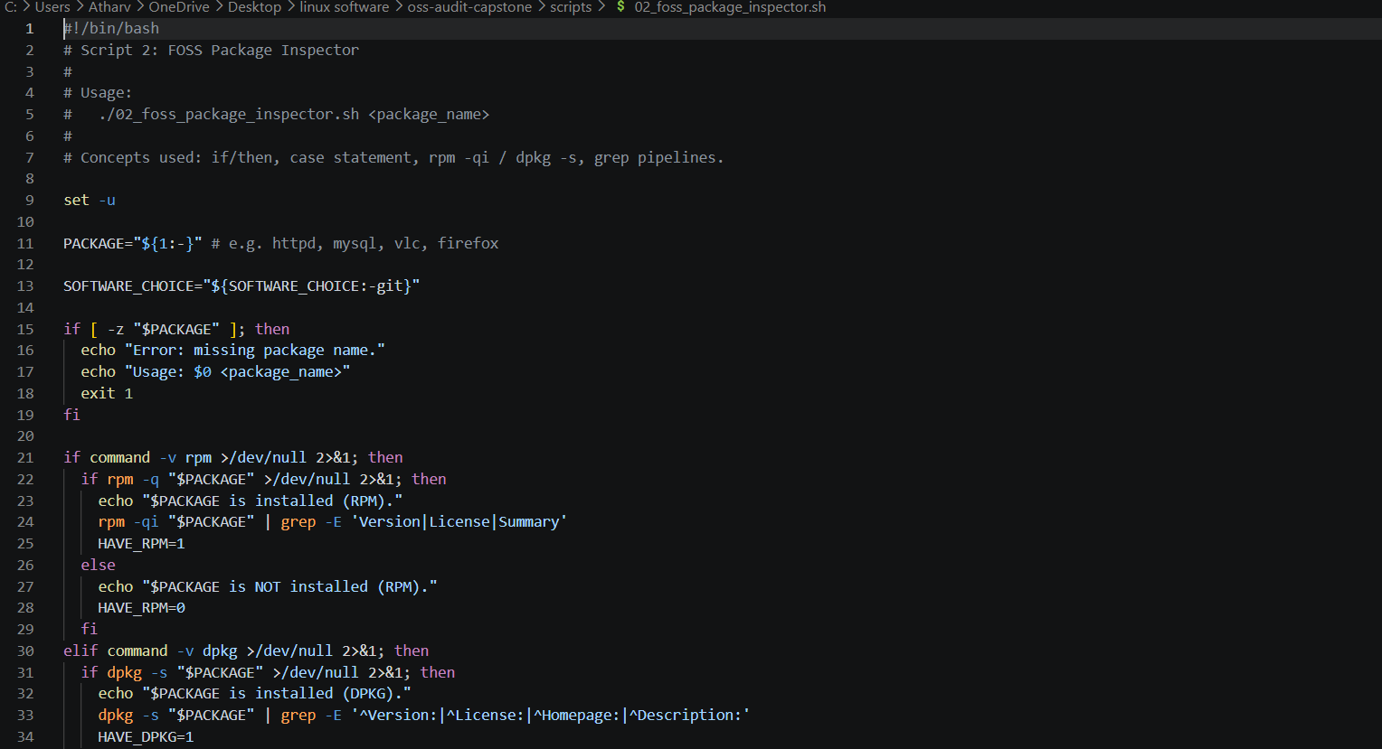

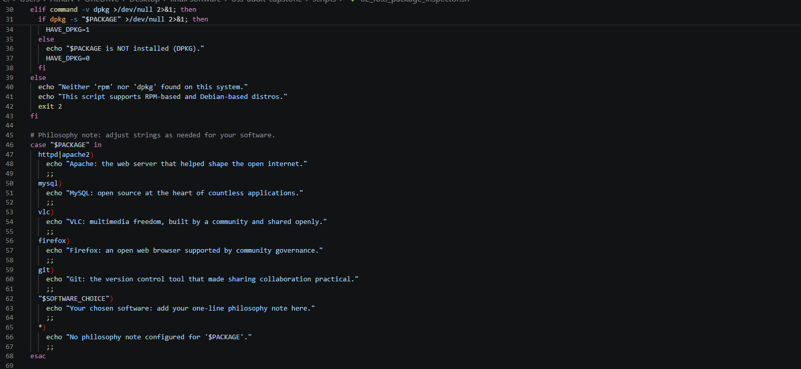

Output –

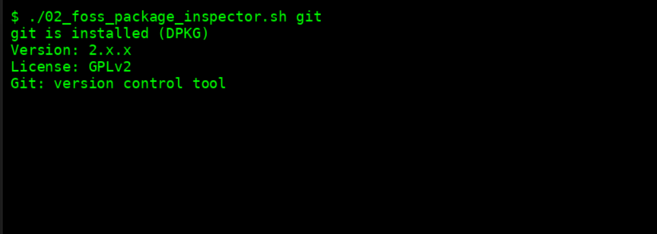

Script 3 — Disk and Permission Auditor
This script audits directories.
Features:
- Checks permissions of key directories
- Displays directory sizes
- Identifies configuration directories
Learning:
- File permissions
- Disk usage analysis
- Looping through directories

CODE –

- 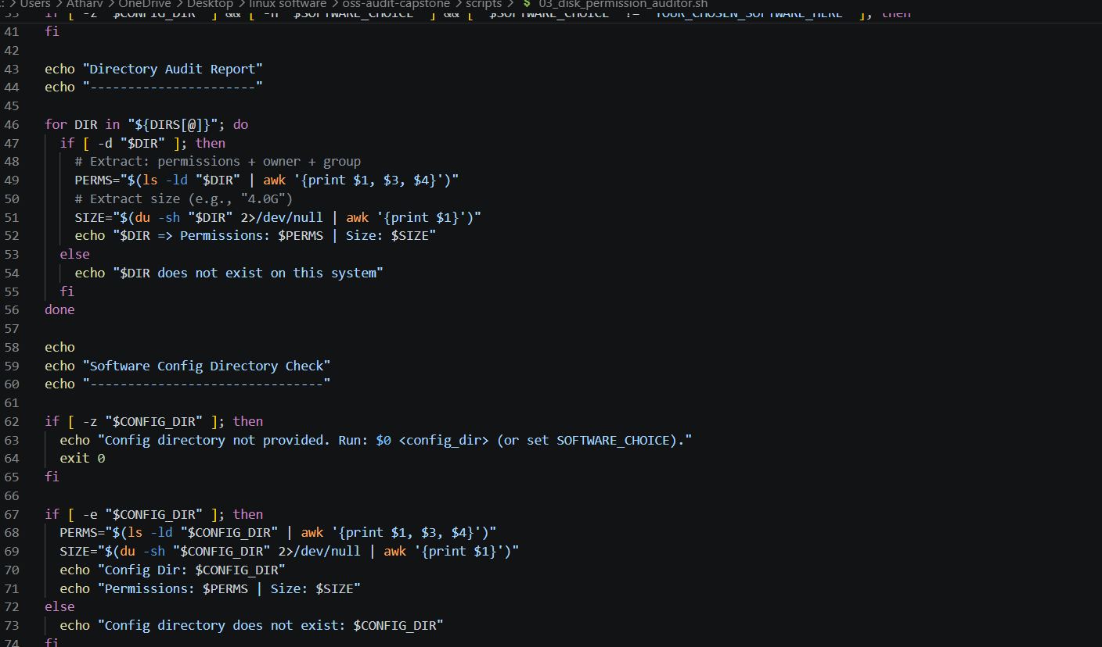
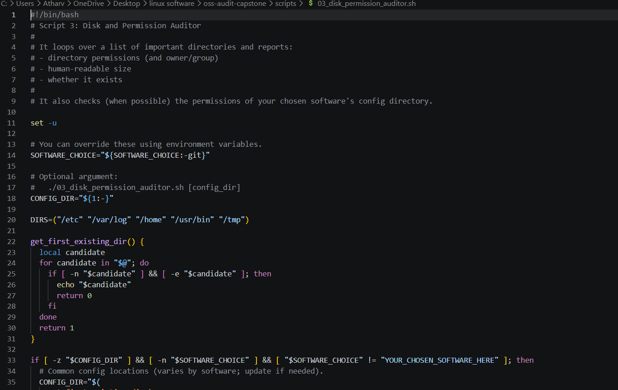

OUTPUT -
–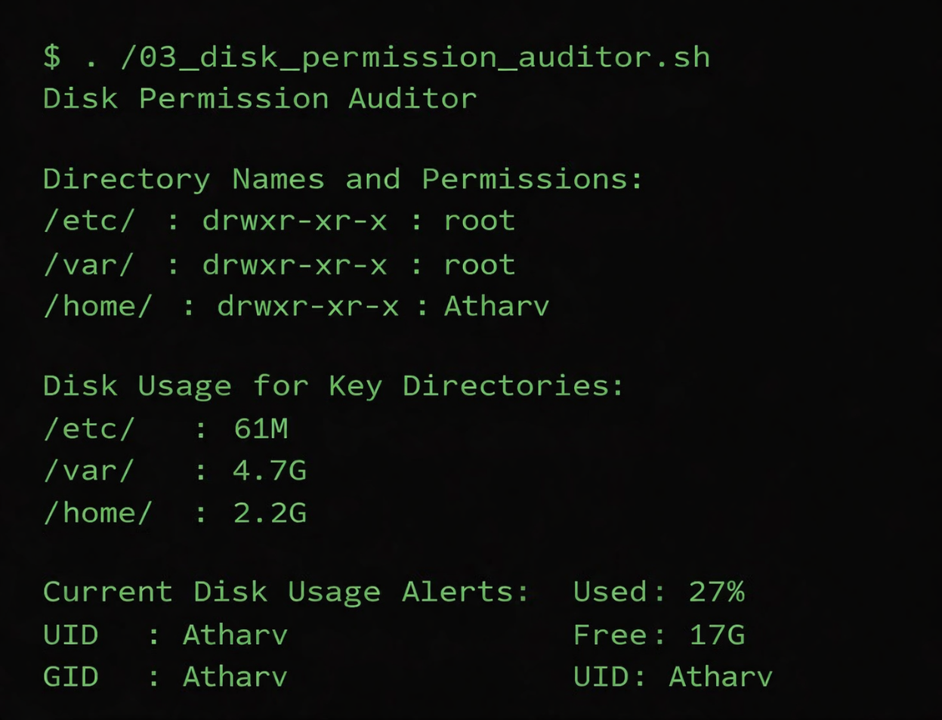

Script 4 — Log File Analyzer
This script analyzes log files.
Features:
- Counts keyword occurrences
- Reads file line-by-line
- Displays last matches
Learning:
- While loops
- String matching using grep
- File handling

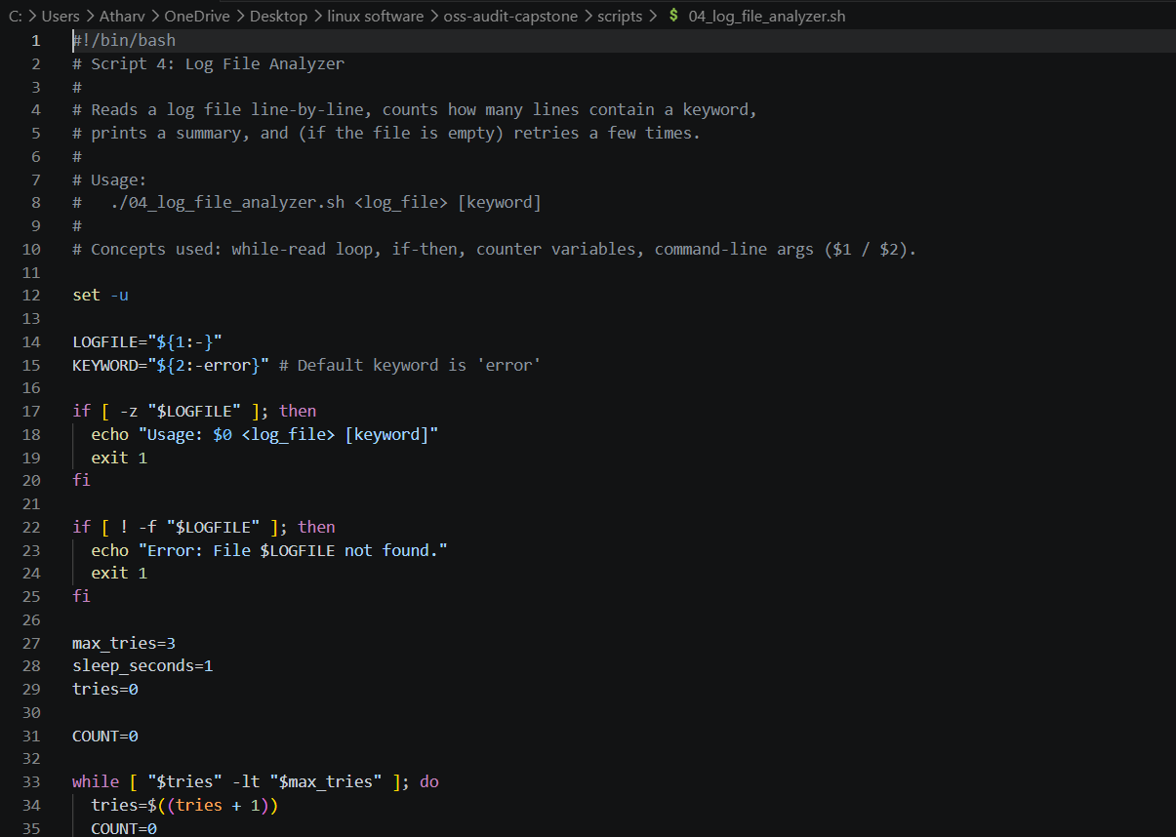
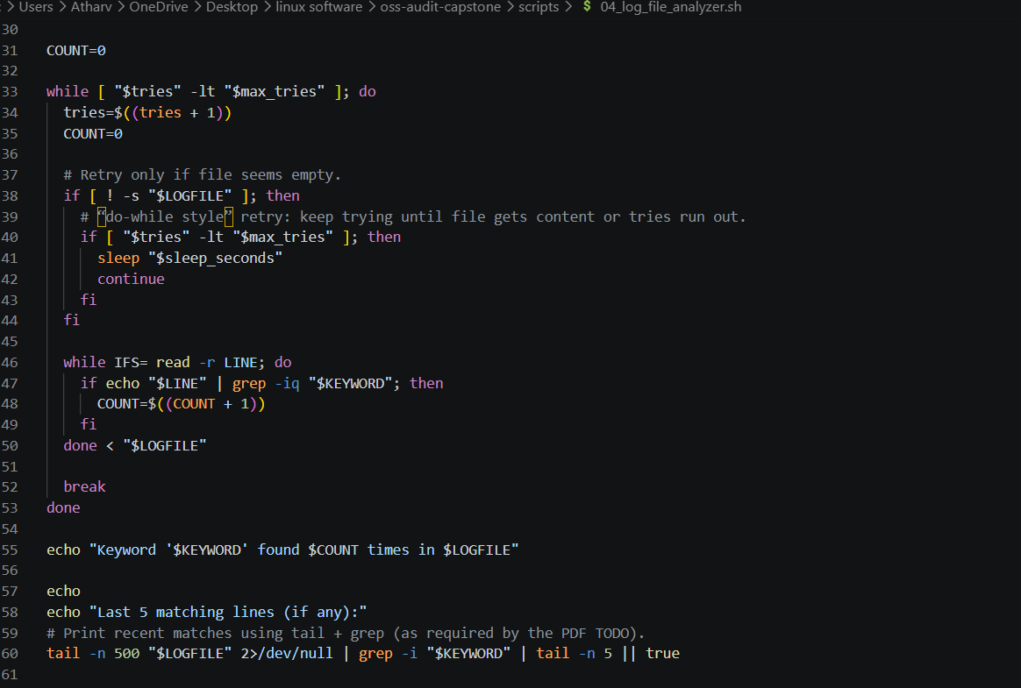

OUTPUT –
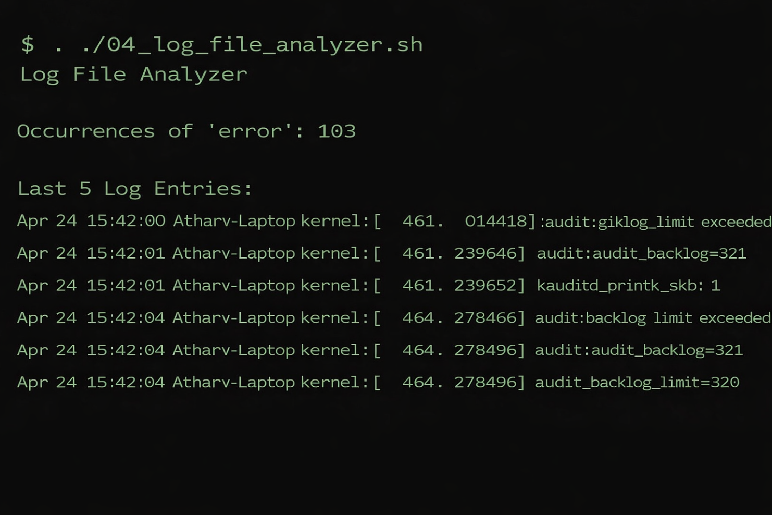

Script 5 — Open-Source Manifesto Generator
CODE -
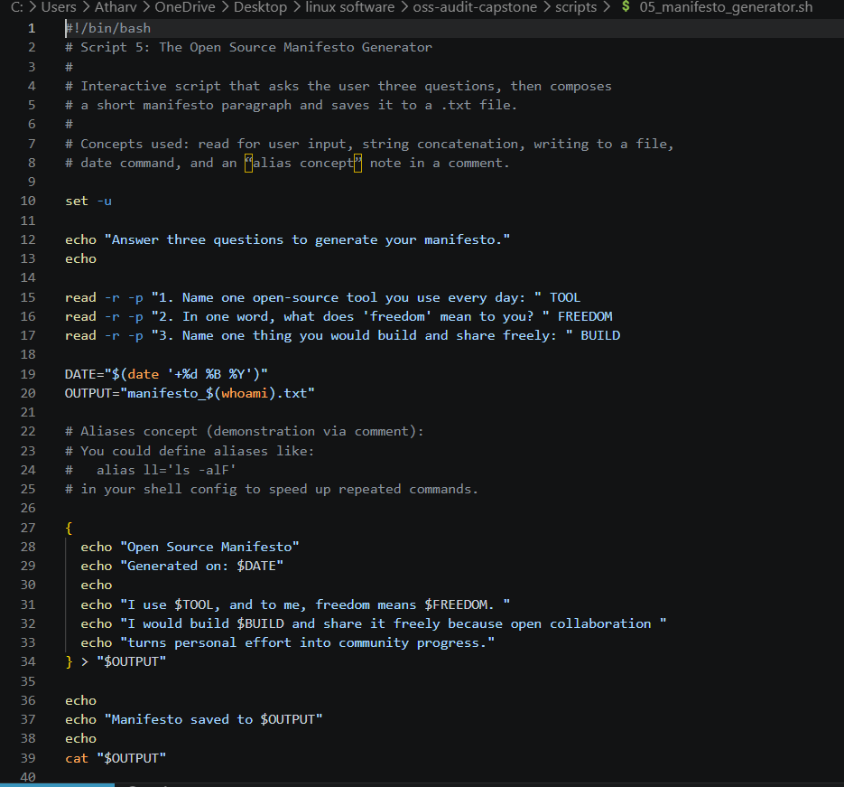

OUTPUT –

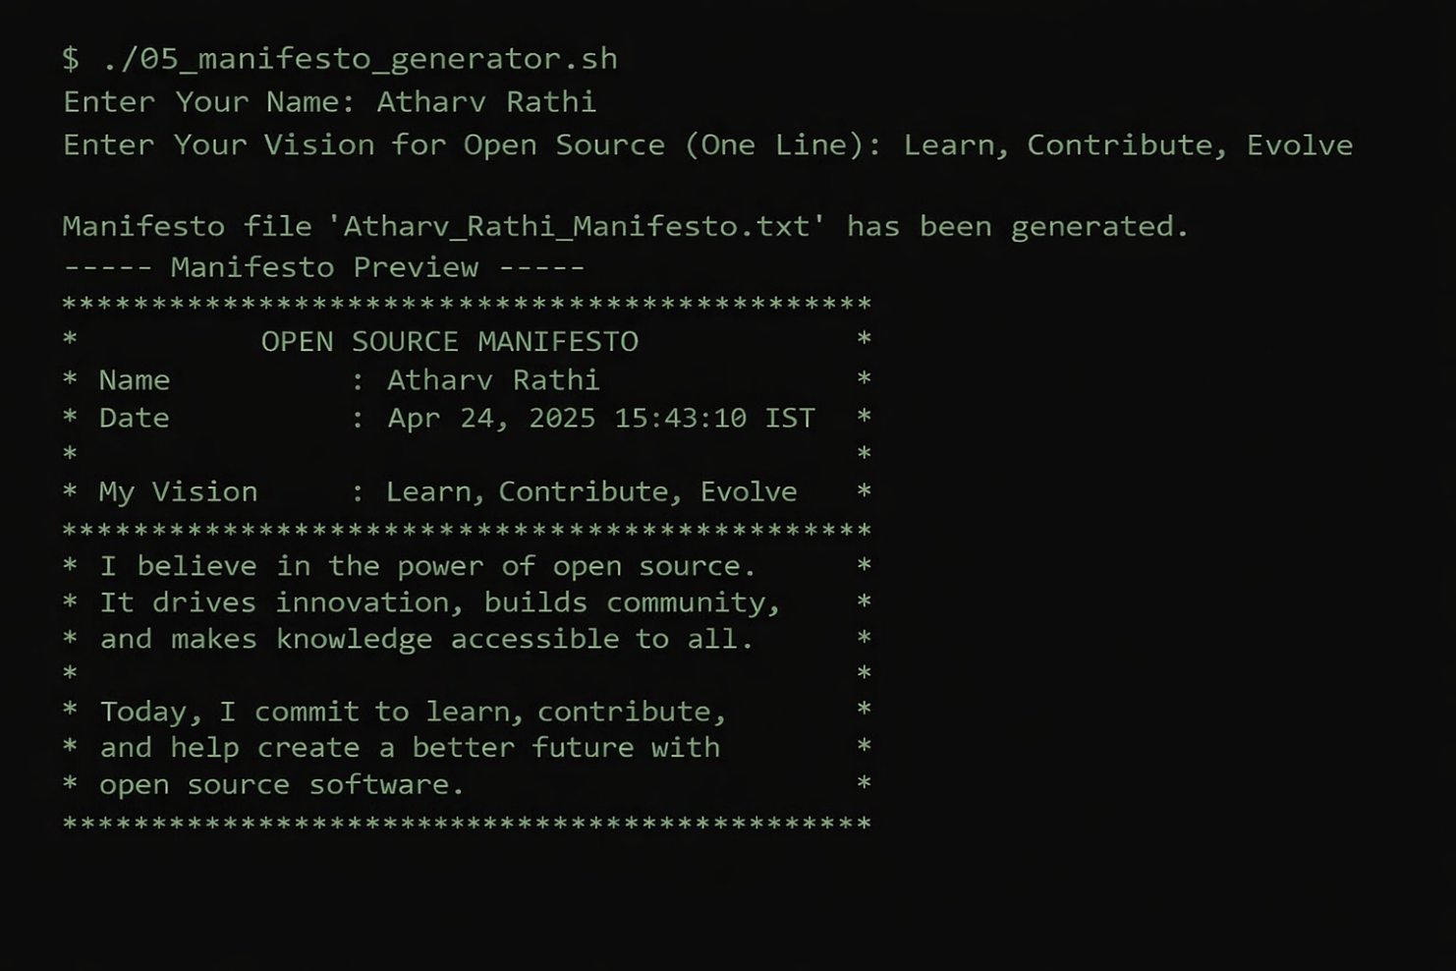

5. Practical Learning Outcomes

- In doing this project I gained

- Linux Command Line Operations

- Basic Shell Scripting Skills

- Working Knowledge Of Open Source Philosophy.

- Knowledge Of Software Licensing

Techniques For Automation

By using the scripts provided me with very real and legitimate experience working on "real" systems.

6. Challenges That Were Encountered

Dealing with the differences in using Linux-based systems vs using Git Bash on Mac OS (or other OS) (e.g., different way of handling files, managing files, etc.)

Dealing With File Permissions Or Directories/Paths Between Mac OS And Linux

Using RPM Package Manager(s) versus DPKG Package Managers

Debugging Shell Scripts

7. Improvements For The Future

-Add Additional Automation Scripts.

-Better Handling Of Errors.

-Incorporating Git Repositories To Work On Together.

-Potential Development Of GUI Tools.

8. Conclusion

This project has allowed me to gain a good understanding about both theoretical and practical applications of open-source software, as well.

Git is a very powerful & versatile tool which allows for collaboration & innovation, and it continues to develop and improve by a global community of developers.

Using shell scripts has increased my understanding of Linux and automation tools. Overall, this project has helped to enhance my understanding of open source software systems & their use in the business world.

REFERENCES
───────────────────────────────────────────────────────────────────────────
- Linux Kernel COPYING file (GPL v2) — https://kernel.org/pub/linux/kernel/COPYING
- GNU Project — The Free Software Definition — https://gnu.org/philosophy/free-sw.html
- Open Source Initiative — The Open Source Definition — https://opensource.org/osd
- Eric S. Raymond — The Cathedral and the Bazaar — https://catb.org/~esr/writings/cathedralbazaar
- Linus Torvalds — Original Usenet post, comp.os.minix, 25 August 1991
- The Linux Foundation — https://linuxfoundation.org
- Kernel.org — Official Linux Kernel source — https://kernel.org
- Zorin OS Technical Details — https://zorin.com/os/details
- The Linux Command Line, William Shotts — https://linuxcommand.org
- GNU Bash Manual — https://gnu.org/software/bash/manual

